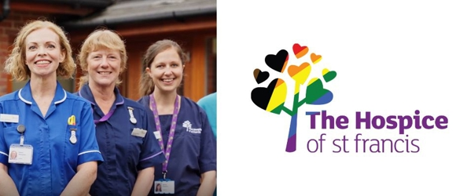

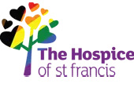

Thank you for your donation

Order Number THANKYOU-01752-70947-YDJL8

Hello Nigel
Thank you for your donation of £145.00.
Your ongoing support is a gift to local families. Thanks to you and people like you, we can support over 2,000 people every year to live their precious lives well.
Your donation will help us raise over £6 million annually to fund our free care. A local charity trusted since 1979, the need for our care is growing faster than ever. Even more care, including complex care, can happen at home and in the Hospice.
If you are a UK tax payer and would like to boost your donation at no extra cost to you by adding Gift Aid to your donation, please contact the Fundraising Department at fundraising@stfrancis.org.uk
Every penny is needed to do what we do.
Thank you!

